EMWP SI Writing Prompt for 6/26/13

Diana Martin

Read Aloud: When I Was Little: A Four-Year-Old’s Memoir of Her Youth.
Written by Jamie Lee Curtis and Illustrated by Laura Cornell

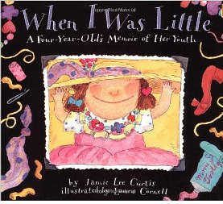
Make a list or expand on one idea.

When I was little, _____________________.

Spin-offs

When I was (any age), ___________ .

When I was in high school, _______ .

When I was single, _____________ .

Before I had kids, ______________ .

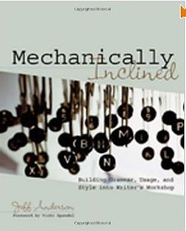
Jeff Anderson, author of Mechanically Inclined, uses this mentor text to teach using a comma with an introductory element in a sentence. He also uses the text as a kick-off for teaching AAAWWUBBIS

Depending on my instructional purpose, I may decide to write the prompt on the board so students can have a model. Sometimes I provide students with AAAWWUBBIS mini-posters to glue directly into their writer’s notebooks as a reference. Once children get a taste for sentence pattern, they begin finding AAAWWUBBIS sentences in books they are reading independently and in academic texts, including math story problems.

