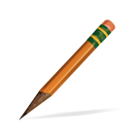  .  Writing Conference  Questions  How’s it going?  What writing work are you  doing today?  What do you need help with?  What part of the writing are  you working on?  What was easy?  What was hard?  What do you think about your  writing?  Questions are from How’s it Going? by Carl Anderson. | Choice Words for Writing  How did you challenge yourself  today?  Did you try any new or difficult  words in your writing today?  What are you noticing about your  writing today?  How’s it going?  What would you like to learn next  as a writer?  How did you figure that out?  What problems did you come  across today?  Where are you going with this  piece of writing?  Questions are from Choices Words by Peter Johnston.

